Linux and Other Related Topics

**Author:** Joshua Lam

**Date:** September 13, 2017

**Abstract:** The following paper will discuss the importance of Linux and its influence on the computer industry. This will be done by looking at the history of Linux, the impact of Linux, and interesting applications.

**1 Introduction**

Every computer engineering student should have some experience with Linux. This operating system is one of the most prevalent and utilized platform. There are many advantages to using Linux that may not seem apparent to the everyday user, but computer engineers find these advantages to be life and money savers. This paper will discuss the history and importance of Linux and how it has steered the computer engineering and science world to where it is today. This paper will include the following sections: 2 Architecture of Linux, 3 History of Linux, 4 Why Linux?, 5 Linux Development and Maintenance, 6 POSIX API, 7 Linux Distributions, 8 Related Linux Operating Systems, and 9 Conclusion.

**2 Architecture of Linux**

Linux is an *operating system* which is “a collection of software that manages hardware resources and provides an environment where applications can run” [3]. The Linux operating system consists of two parts the Linux kernel and the additional user applications.

**2.1 Linux Kernel**

The *kernel* is the core of an operating system and consists of the “modules or sub-systems that provide the operating system functions” [1]. The Linux Kernel is written entirely in the C programming language. The kernel is made up of the user space and the kernel space. The user space is where the processes of a user on the computer run. This memory and space is protected and the system is designed so that one process can not interfere with another one. Only kernel processes can access a user process. A user process can also have access to the kernel services provided through a kernel process through system calls. This lets the user still use the system services without affecting the whole kernel negatively. The following figure illustrates this architecture.

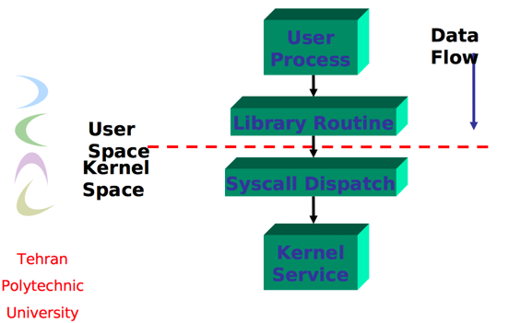

*Figure 2.1 Linux Kernel Architecture*

2.1.1 Kernel Functions

So, what are these kernel services that are offered to the user processes? These include access to the file system, process management, device drivers, memory management, and networking. The kernel is the layer that communicates with a computer’s hardware components and allows the user to have access to the resources provided by the hardware. The following figure illustrates this layer of services being accessed by system calls.

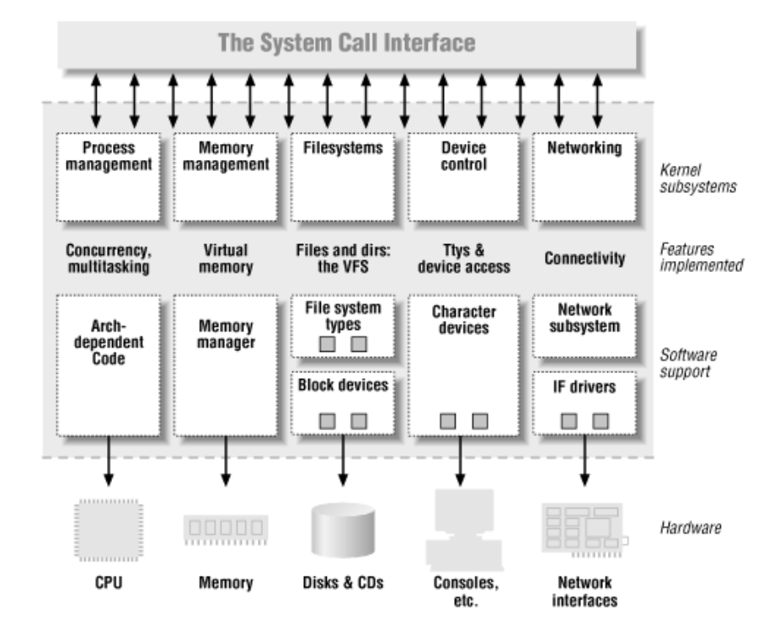

*Figure 2.2 Service Layer*

**2.2 User Applications**

With only the kernel a user could operate using a command line interface. They would be able to execute programs and read and write to memory. To compete with the other operating systems available today Linux has also included many user applications for convenience. These “include system libraries, graphical user interfaces, email utilities, web browsers, and other programs” [3]. Some applications include google chrome browser, a graphical user interface so users can move a cursor around to navigate throughout the computer, and system libraries that can be easily imported for more functionality.

**3 History of Linux**

**3.1 Unix**

Linux is not to be confused with *Unix*. In the late 60’s and early 70’s people were starting to use super computers to perform calculations and other tasks. Back then each computer ran its own software and operating system specific to the job it had to get done. Programs were not transferrable and machines basically operated on their own. A team of developers at Bell Labs started to work on a software solution that would solve these issues. They wanted it to be portable, simple, and easy to use. They wrote the new operating system in C and dubbed it Unix. Unix quickly became a hit and throughout the next couple of decades Unix could be found on more and more supercomputers and large mainframes. However, Unix was kind of slow when on a personal computer and was very expensive. This was around the time when personal computers became household items and people resorted to using MS DOS or windows.

**3.2 Linus and the Solution**

Linus Torvalds was a student at the university of Helsinki in the computer science department in the early 90’s. He wanted to run Unix on his home computer but found out that it was expensive and not practical for that setup. So, he set out to find a solution and started an open source project called Linux. “From the start, it was Linus’ goal to have a free system that was completely compliant with the original Unix” [2]. Therefore, he wanted to know what the *Posix* standards were. The following figure shows his first blog post on the way to creating Linux.

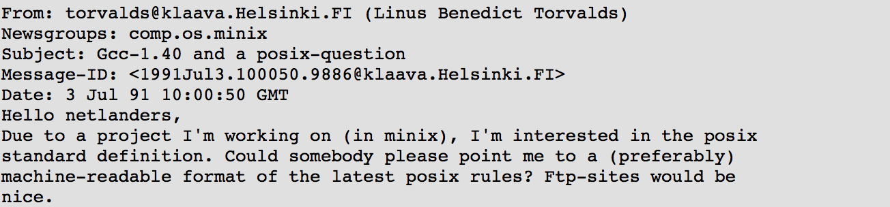

*Figure 3.1 Linus’ Blog Post*

**4 Why Linux?**

The number one reason why Linux is used to frequently around the world is the simple fact that it is open-source and free. Linux is also very secure and for this reason many of the world’s biggest companies have chosen Linux as the base of their software. These include Google, Amazon, and Facebook who trust Linux with running their web servers. They have not only chosen Linux as the base of their software but they have also trusted Linux to be the operating system running on their servers that hold all the valuable client and customer information. “Today Linux powers more than 90% of web servers” [4]. Linux has a plug and play nature and thus can be implemented for a wide array of applications like the ones aforementioned as well as android phones, large servers, and even routers. “The small footprint of Linux allows it to run on older hardware or on embedded systems” [3]. Finally, because Linux is open source a user can use it in any way they desire and modify to fit their needs.

**5 Linux Development and Maintenance**

As previously mentioned Linux is open source and not one company owns Linux. Linux is developed by a community of users who contribute in their free time. The community has over 10,000 developers and over 1,000 companies [4]. Linux is the largest collaborative software development project in the world with over 15 million lines of code. Linux also has a very fast turn over time for new operating systems. Every 2-3 months a new kernel is pushed out to users. This large rate is accomplished by Linux’s unique collaboration technique. “Developers break changes into individual units called *patches”* [4]. A patch can be code that must be changed, removed, or added to add a new feature, support a new device, fix a problem, or improve performance. Patches are then posted to the mailing list where other developers can help improve the code and give feedback. Once the patch is almost ready it is reviewed by a senior Linux kernel developer who tests the patch even further. A senior Linux developer is only in charge of one or more sections of the 100 Linux sections. This allows the code to be developed in modules making it independent of other code other developers are working on. Once the senior Linux developer is satisfied and signs off on the patch, the patch will be presented to Linus himself who has the final say if the patch will be a part of the new kernel release.

**6 Posix API**

Posix stands for the Portable Operating System Interface and it is a “set of standard operating system interfaces based on the Unix operating system” [5]. The need for Posix arose because of some of the problems mentioned previously such as there not being a standard among the computers the industry was using. People and businesses wanted to be able to develop programs that were transferrable to other enterprise machines. The Posix API was developed by the *IEEE* or the Institute of Electrical and Electronics Engineers. Posix is a set of standards and for example Posix.1 is the standard for the API in the C language while Posix.2 is the standard shell and utility interface.

**7 Linux Distributions**

Due to the open source nature of Linux there have been many operating systems that have been developed with Linux being the core system under the hood. These *Linux distributions* are also mostly open source and are created and developed almost the same way the original Linux operating system was. This section will discuss two of the more popular Linux distributions, Debian and Fedora.

**7.1 Debian**

Debian was developed with the focus of providing services and software to users easily and all in one place. Debian gets its name from Ian Murdock and his wife Debra who are the creators. “Debian comes with over 51,000 *packages* (precompiled software that is bundled up in a nice format for easy installation on your machine)” [6]. Debian also has a package manager installed which allows for easy installation of packages and these packages are free. The development of Debian is a collaboration between many interested parties. People who like to help others, write programs to learn more about computers, and want more free software are some of the contributors. The development is done by almost a thousand active developers who volunteer their time. They communicate through email and have probably never met face to face. Debian is a free download online but they also offer a hard copy on CD for download that is not free. This is so that they can help pay for domain registrations and hardware needed to support the project.

**7.2 Fedora**

Fedora is another Linux distribution created by the company Red Hat. “The Fedora Project is a partnership of Free software community members from around the globe” [7]. Fedora has a mission of providing and protecting the open source software community. But red hat is also a billion-dollar company so how do they make money from open source software? Fedora is the open source operating system that is where they run test runs for their paid for enterprise version RHEL (Red Hat Enterprise Linux). “Fedora and RHEL have a mutually beneficial relationship, with Fedora code serving as something of a testing ground for the enterprise features delivered to Red Hat’s paying customers” [8]. RHEL is advertised as always going to work which is a big draw for large companies looking to invest on a stable and reliable operating system for their server rigs. Red Hat also brings in revenue from offering support to their clients for troubleshooting issues as well as training for new customers so that they know how to use the products.

**8 Related Linux Operating Systems**

**8.1 Android**

The android operating system created by google is often related to Linux in many resources. This is because it uses the Linux kernel at its core. It is not a Linux operating system however because after the core Linux kernel, android deviates from anything else Linux. “Google hasn’t added all the typical software and libraries you’d find on a Linux distribution” [9]. Google has also designed it to fit their own needs which they can do because Linux is open source software. Therefore, a Linux system cannot run an android application and vice versa.

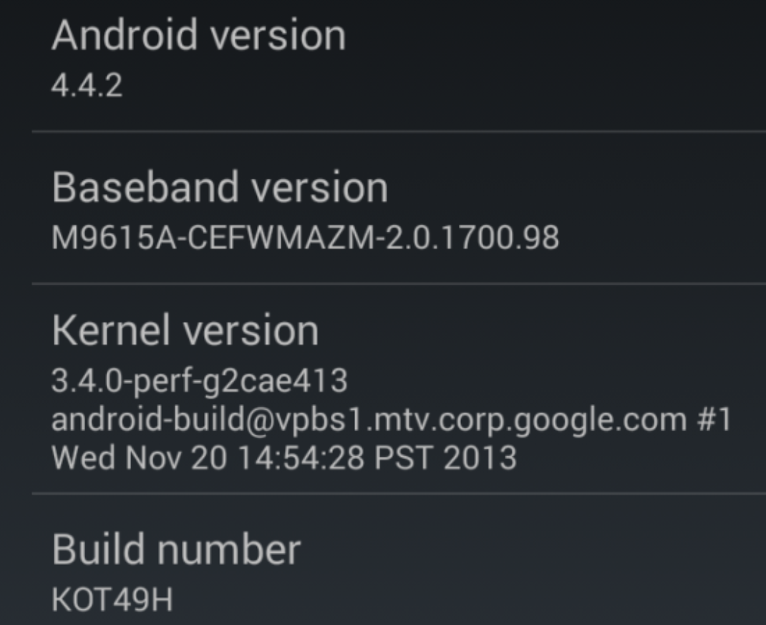

*Figure 8.1 Android Settings Information Displaying Kernel Version*

**8.2 Raspberry Pi**

Raspberry Pi is a low-end computer that can run the Linux operating system. It was originally built for education purposes and was a success due to its low-cost design, small size, and price [10]. A Raspberry Pi can run a Linux operating system and was built specifically to house these programs. Two popular ones are Raspbian and Pidora which are the raspberry pi versions of the previously discussed Linux distributions Debian and Fedora. Raspberry Pi offers a huge advantage to users because it can run a full operating system unlike the Arduino boards which is basically only a microcontroller. Some applications of Raspberry Pi are running a simple server for a home network, maintaining simple systems that an engineer designs, and doing the processing of some embedded system.

**9 Conclusion**

From one college students’ passion arose Linux, the operating system behind many of the world’s computer processing. Linux is completely open source and many companies and people have used this to launch their own companies. Without the open source label, I don’t think Facebook, Amazon, or Google would be where they are today because they are built on the Linux operating system and kernel. Linux is something every student should have some experience with and will help them to gain valuable insights. Maybe there is something about Linux that you don’t like so why not follow in Linus’ footsteps and fix it.

REFERENCES

1. “Linux System Architecture”, Payberah, Amir Hossein. Tehran Polytechnic University Power Point. https://www.sics.se/~amir/files/download/os-lab/linux1.pdf
2. “Introduction to Linux”. http://www.tldp.org/LDP/intro-linux/html/sect_01_01.html
3. “What is Linux?”, Linux Training Academy. https://www.linuxtrainingacademy.com/what-is-linux/
4. “Have You Ever Wondered How Linux is Built and Maintained?”, Venigalla, Ganesh. January 31, 2017. http://curiouspost.com/how-linux-is-built-and-maintained/
5. “POSIX (Portable Operating System Interface)”, Rouse, Margaret. http://whatis.techtarget.com/definition/POSIX-Portable-Operating-System-Interface
6. “Introduction to Debian”. June 6, 2017. https://www.debian.org/intro/about#what
7. “Fedora Project”. February 16, 2016. https://fedoraproject.org/wiki/Overview
8. “How Red Hat killed its core product – and became a billion-dollar business”, Brodkin, Jon. Febuary 28, 2012. https://arstechnica.com/information-technology/2012/02/how-red-hat-killed-its-core-productand-became-a-billion-dollar-business/
9. “Android is Based on Linux, But What Does That Mean?”, Hoffman, Chris. May 12, 2014. https://www.howtogeek.com/189036/android-is-based-on-linux-but-what-does-that-mean/
10. “What is a Raspberry Pi?”. https://opensource.com/resources/raspberry-pi